HINTS ON SAMPLE PREPARATION
Please read the following notes when preparing for your XAS experiments. (Apologies if you are not a novice.)
- In an XAS experiment it is important to have the right amount of target atom in the beam for good transmission data. Too much and the beam will not get through or too little will mean no absorption. The typical weights of sample are around 5 to 50mg per cm².
- Given the very low weights of material it is usual to mix the sample with another material that will not absorb the usual range of X-rays (i.e. contains elements like C, H, O, N, B, etc.) and pressed into a pellet. We prefer cellulose but there are a range of other diluents, such as boron nitride, PVP, fine powdered polythene, etc.
- We prefer to use 13 mm diameter IR pellets for the BAG experiments although other sizes can be used. We have 32 hole racks to mount the pellets so that we can program the scans to run remotely. The beam is very small (it can be as low as 300 microns) so there is plenty of area to hit in most samples. Calculating the correct weight of sample is possible with a number of programmes. I prefer absorbix which is a programme from the CNRS and downloadable from the Web. I like it as you can put in the whole chemical formula and it will give the weights for all atoms in the sample. The only caution is that it assumes a 1 cm² pellet so the weights have to be corrected to a 13 mm pellet.
- It is crucial that the pellet is uniform and not grainy (due to the small size of the beam). This means thoroughly grinding the sample and diluent before pressing. The weight of diluent in the case of cellulose can be 100 mg, although if the target atom is light (V, Ti, Ca) it should be 50 mg.
- If you have air sensitive samples then they need to be sealed in aluminised, heat sealable plastic bags (available from Sigma Aldrich). These are X-ray transparent in the region we work.
- We have very recently mounted samples into a rack and heat sealed the whole rack in an aluminised bag, the whole operation being performed in a glove box. Hence if you would like to study a number of air-sensitive samples we can send you a rack that will take 32 13 mm pellets. The arrangement is shown in the figure below.

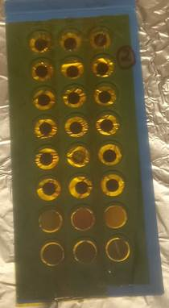
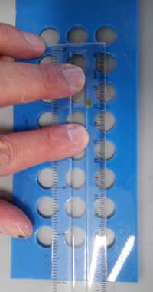
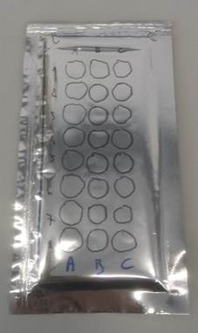
- All of the above points are for transmission measurements. There two other methods of collecting XAS spectra; Fluorescence yield (FY) Total Electron Yield (TEY).
- When the sample is very dilute in target atom (<1 atom %) then spectra can be collected by measuring the fluorescence X-rays. These result from electrons dropping down orbitals to fill the hole left by the emitted photoelectron. The fluorescence output is proportional to the absorption. This is a standard experiment on B18 and a fluorescence detector is permanently in place. So there is relatively little extra work in setting up for data collection. 13 mm pellets are still used but you will need to contact me to find the correct weight of sample and diluent.
- Transmission and FY measurements are effectively bulk measurements. The fluorescent X-rays are coming from some 50 nm into the surface (it depends on the nature of the target atom). Spectra can also be collected by collecting the photoelectrons emitted from the sample, TEY. In this case the measurement is very surface sensitive, ~2 nm, as the electrons have to escape from the sample. TEY requires a special chamber in which the sample can be flushed with helium to give a reasonable path length for the emitted electrons. The system takes a longer setting up time so we tend to use it only when the proposal makes a good science case. The BAG has used it very successfully on samples from Tarascon and Grimaud’s group at College de France (J. Phys. Chem. Lett., 8, 3466, 2017; ACS Energy Lett., 3, 2884, 2018)
Alan Chadwick 31/07/2019

